

**Name: Preetam Kumar**

**Semester/dept: BSCS - iii**

**Subject: Digital Logic Design**

**Instructor: Sir Rafay Shaikh**

**PRACTICAL NO 3**

**Q:1** Simplify given expression using Standard Sum of Product, also show step by step process of building a circuit and designing a truth table.

1. F1(A,B,C) = A’B’C + BC’ + AC’

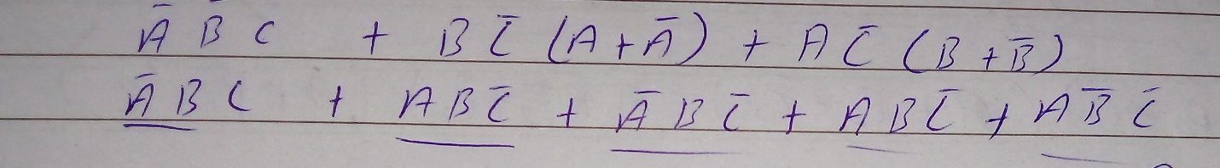

TRUTH TABLE:

|  |
| --- |
|  |

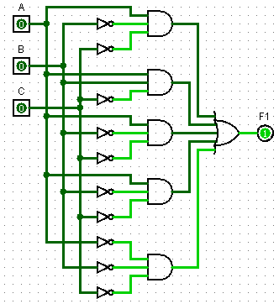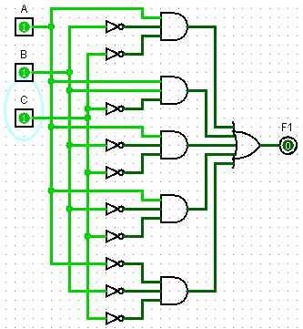

1. F1(A,B,C,D) = A’B’C’D’ + ABC’ + AC’

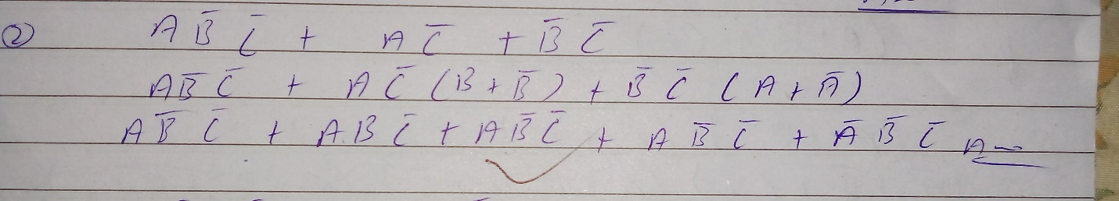

TRUTH TABLE:

|  |
| --- |
|  |



1. F1(A,B,C,D) = A’B’C’D’ + ABC’ + AC’

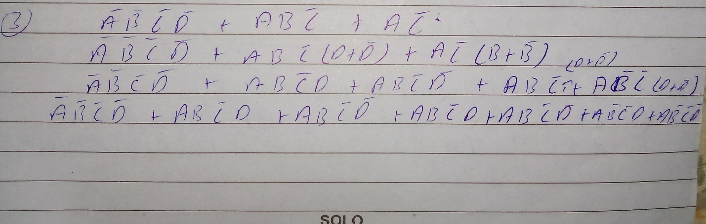

TRUTH TABLE:

|  |
| --- |
|  |

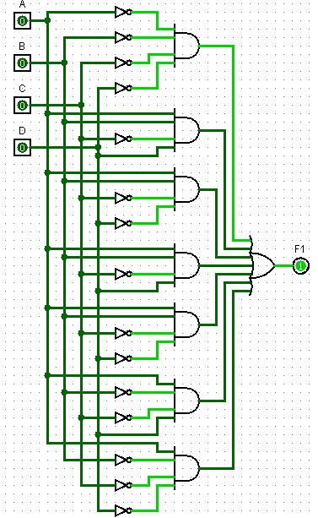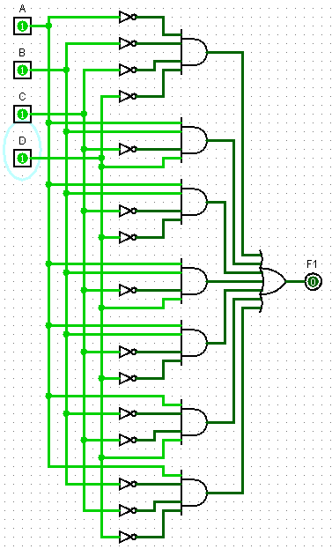

Q:2 Simplify given expression using Standard Product of Sum, also show step by step process of building a circuit and designing a truth table.

1. F1(A,B,C) = (A’+B’+C )( B+C’) ( A+C’)

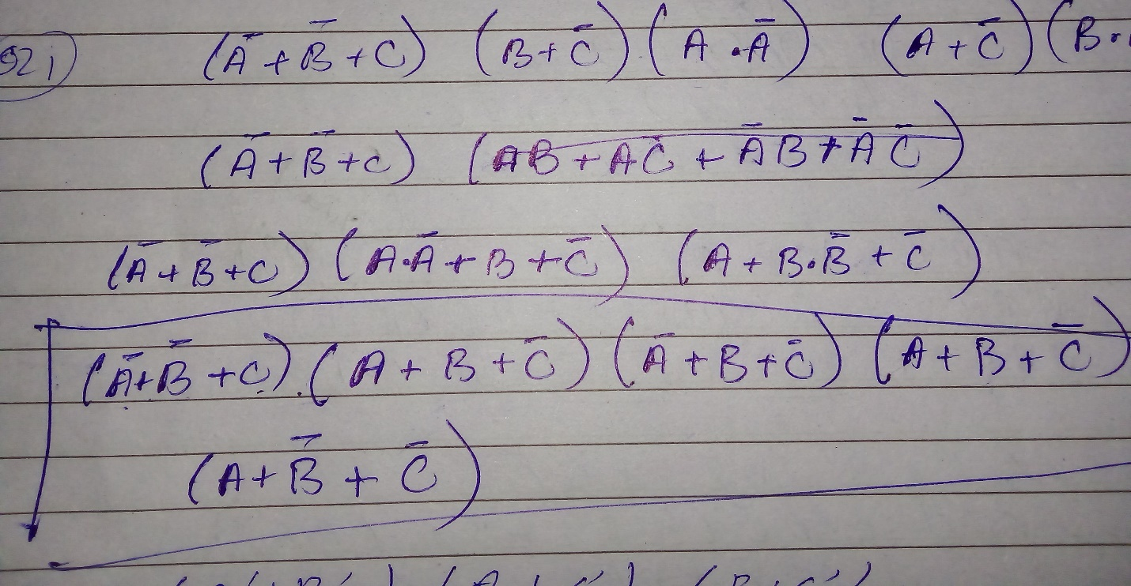

TRUTH TABLE:

|  |
| --- |
|  |

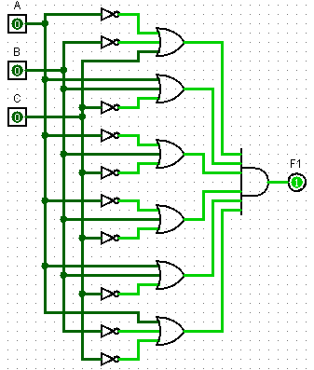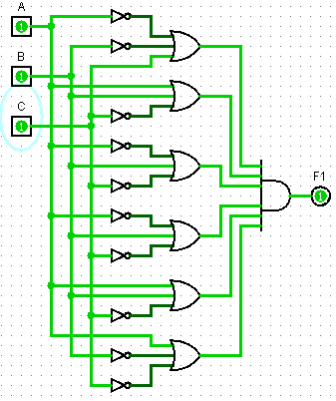

1. F2(A,B,C) = (A’+B’ )( A+C’) ( B+C’)

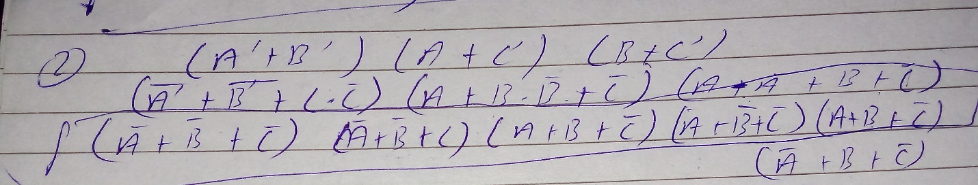

TRUTH TABLE:

|  |
| --- |
|  |

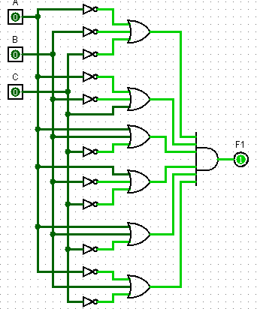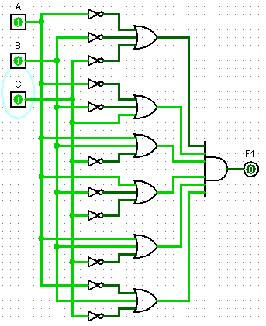

1. F1(A,B,C,D) = (A’+B’+C+D )( B+C’+D) ( A+C’)

TRUTH TABLE:

|  |
| --- |
|  |

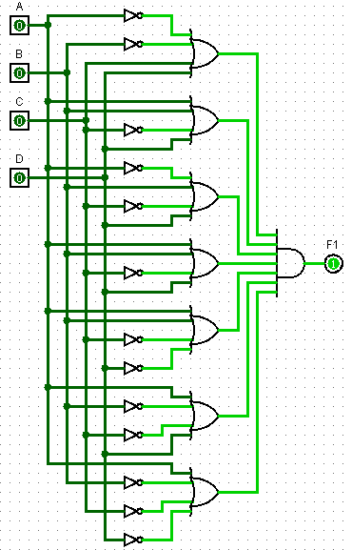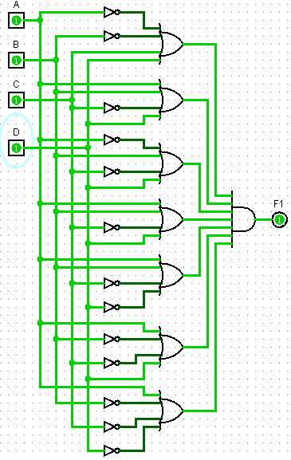

Q3: Why do we convert SOF & POS into their Canonical form?

ANS: It is applicable to systems that are not linear. It may be used with systems that are tile invariant. It is applicable to systems with many inputs and multiple outputs. It provides insight into the system's internal status.

Q:4 What is Combinational Analysis?

ANS: A subsystem of Logisim called *Combinational Analysis* can convert between regular logic circuits and their corresponding Boolean expressions and truth tables.

Q:5 What are minterms and Maxterms?

ANS: A minterm is a Boolean AND function containing exactly one instance of each input variable or its inverse. A maxterm is a Boolean OR function with exactly one instance of each variable or its inverse.

THANK YOU